Forming the synthetic features Ψ(r), step by step
A plain-language guide to formulas (1)–(6) of the article with a fully worked example — 6 objects, 2 mixed features, 2 classes — up to the input of the hierarchical agglomerative grouping
Synthetic features turn the neighbourhood of every object into a few simple numbers. This guide explains in everyday words how §1.2–1.5 of N. A. Ignatev’s article “Ансамбли алгоритмов распознавания на основе синтетических признаков и контекстов k ближайших соседей” (Ensembles of recognition algorithms based on synthetic features and contexts of k nearest neighbours) forms the set of synthetic features Ψ(r) with formulas (1)–(6), and then walks through every calculation on a small example — every formula, every intermediate number and the reason for each step — up to the data that the hierarchical agglomerative grouping receives.
The example has the same structure as the experiments — a quantitative and a nominal feature, two classes, the Zhuravlev metric, k taken from the k rule — with 6 objects, the smallest sample the k rule allows. It is the example of the earlier version of this document with two values changed (x₁ of S₃: 70 → 10 and x₁ of S₅: 80 → 20), so that every situation of the calculation now appears (Section 14). All numbers were produced by the Python engine of the Context-Synthetic Model experiment. Quotations from the article are translated from Russian.
Synthetic features in one paragraph. Look at the k nearest neighbours of an object. Count how many of them belong to K₁ and how many to K₂: the majority class becomes the object’s synthetic feature a = 1 or 2 (formula (5)) — a value that can be computed even for a new object whose class is unknown. Count also how many neighbours share the object’s own class: this number μ (0 … k) says how typical the object is. On the training sample, formula (1) turns each value of μ into a membership degree f between 0 and 1, formula (3) places a boundary G on the f axis, and formula (4) counts how many objects the boundary puts on the side of their own class — the weight ω of the feature. Formula (6) finally replaces every value a = 1 or 2 by its contribution η, a signed number that says towards which class the value points and how strongly. Repeating this for several distance functions (and several k) gives the set Ψ(r); its contributions and weights are the input of the hierarchical agglomerative grouping.
Contents. 1 The idea in one picture · 2 Words and symbols · 3 The procedure at a glance · 4 The example dataset · 5 Step 0: preparing the data · 6 Step 1: the nearest neighbours · 7 Step 2: formula (5) · 8 Step 3: formula (1) · 9 Step 4: formula (2) · 10 Step 5: formula (3) · 11 Step 6: formula (4) · 12 Step 7: formula (6) · 13 The result: the input of the grouping · 14 The whole calculation at a glance · 15 Why each piece is there · 16 What the article leaves open · Appendices A–D

1. The idea in one picture
Take an object S and its k nearest neighbours (Figure 1). Two simple counts describe that neighbourhood:
- χ₁ and χ₂ — how many neighbours belong to K₁ and to K₂. Their majority is the synthetic feature a ∈ {1, 2} (formula (5)). It does not use the class of S, so a new object gets its value in exactly the same way.
- μ — how many neighbours belong to the own class of S. This number (from 0 to k) is called the gradation. It is used only on the training sample, to judge how useful the feature is: formulas (1)–(4) turn the gradations into a membership degree f, a boundary G and a weight ω.
Formula (6) then combines the value a with the weight ω into a contribution η. Doing all this for several distance functions — and, in larger samples, several values of k — gives the set of synthetic features Ψ(r).
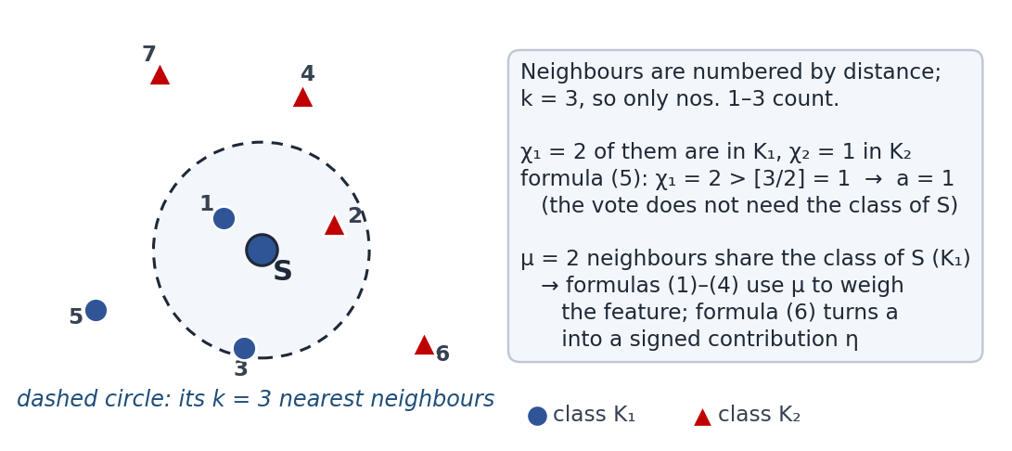
Figure 1. The two counts of one object (schematic picture, k = 3). Only the three nearest neighbours — inside the dashed circle — take part.

2. Words and symbols
Symbol or word | Meaning
E₀, m | The training sample and its size; here m = 6.
K₁, K₂; |K₁|, |K₂| | The two classes and their sizes; here 3 and 3.
x₁, x₂; I, J | The features; I is the set of quantitative features (here x₁), J the set of nominal features (here x₂).
ρ, ρ_{I}, ρ_{J} | Zhuravlev distance on all features, on the quantitative features only, on the nominal features only; ρ = ρ_{I} + ρ_{J}.
k | Number of nearest neighbours; an odd number; here k = 3.
χ₁(S_{j}, k), χ₂(S_{j}, k) | How many of the k nearest neighbours of S_{j} belong to K₁ and to K₂; χ₁ + χ₂ = k.
[k/2] | The integer part of k/2; for k = 3 it is 1.
a | Value of a synthetic feature by formula (5): 1 or 2, the majority class of the neighbours.
gradation μ | How many of the k nearest neighbours belong to the object’s own class: 0, 1, …, k.
d_{1k}(μ), d_{2k}(μ), n(μ) | Numbers of objects of K₁ and of K₂ with gradation μ; n(μ) = d_{1k}(μ) + d_{2k}(μ).
f_{k}(μ) | Membership function (1): how strongly gradation μ points to K₁, from 0 to 1.
g(S, k) | Membership of the object S: f_{k}(μ) taken at its own μ (used in formula (4)).
g_{k} | Stability (2) of the feature: 0.5 = no difference between the classes, 1 = full difference. Not the same as g(S, k).
β | The largest gradation in formula (2); here β = k.
q₁, q₂, G_{k} | Smallest f above 0.5, largest f below 0.5, and the boundary (3) halfway between them.
ω | Informativeness (4) — the weight of the feature: the share of objects that G puts on the side of their own class.
α¹_{j}, α²_{j} | Numbers of objects of K₁ and of K₂ whose feature value is a = j.
η(j) | Contribution (6) of the value a = j: positive points to K₁, negative to K₂.
Ψ(r) | The set of synthetic features: one feature for every distance and every permitted k.
grouping (HAG) | The hierarchical agglomerative grouping of §1.5, which receives Ψ(r), the weights ω and the contributions η.

3. The procedure at a glance
§1.2 of the article introduces the membership function (1) and the stability (2) for codes of neighbour classes. §1.3 introduces the number of own-class neighbours μ, and §1.4 applies (1) and (2) to it with β = k. §1.5 defines the boundary (3), the weight (4), the binary feature (5) and the contributions (6), and states that Ψ(r), the weights (4) and the contributions (6) are the input of the grouping. At the end of §1.5 the article proposes building synthetic features with different metrics, or with one metric on different groups of features (only nominal, only quantitative) — the three distances ρ, ρ_{I} and ρ_{J} of this example. Figure 2 shows the whole procedure.
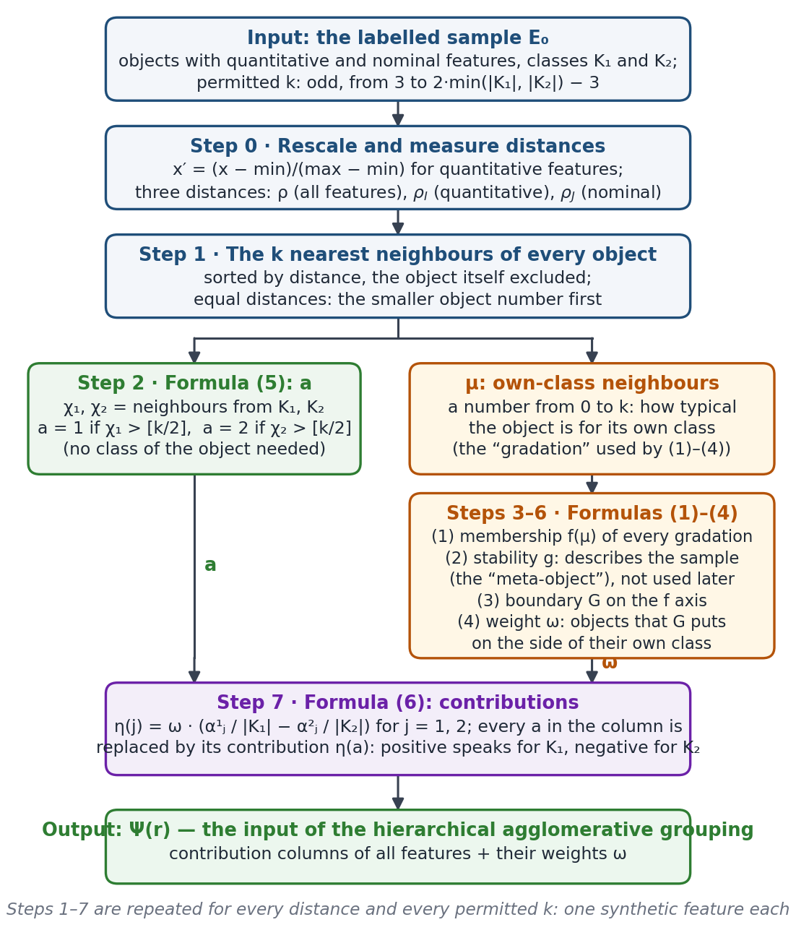
Figure 2. Forming one synthetic feature. The left branch (formula (5)) gives the values that every object — also a new one — receives; the right branch (formulas (1)–(4)) needs the classes and decides how much the feature is worth. Formula (6) joins the two.

4. The example dataset
Object | x₁ (quantitative) | x₂ (nominal) | Class
S₁ | 10 | 1 | K₁
S₂ | 20 | 1 | K₁
S₃ | 10 | 2 | K₁
S₄ | 110 | 1 | K₂
S₅ | 20 | 2 | K₂
S₆ | 100 | 2 | K₂
Type | 1 (quantitative) | 0 (nominal) | —
Table 1. The example (m, n, c) = (6, 2, 2): 6 objects, 2 features, 2 classes of 3 objects. Two values of x₁ were changed with respect to the earlier version (marked “was”); the last row holds the type flags as in the workbooks (1 = quantitative, 0 = nominal).
Permitted k. The workbook experiments use odd k from k_{min} = 3 up to k_{max} = 2·min(|K₁|, |K₂|) − 3. Here k_{max} = 2·3 − 3 = 3, so k = 3 is the only value. This is also why 6 objects is the smallest possible sample: k = 3 needs at least 3 objects in each class.
Three features. With one k and three distances the set Ψ(r) has three synthetic features:
- a₁ = (ρ, 3) — the 3 nearest neighbours measured with ρ, i.e. on both features.
- a₂ = (ρ_{I}, 3) — the 3 nearest neighbours measured with ρ_{I}, i.e. on the quantitative feature x₁ only.
- a₃ = (ρ_{J}, 3) — the 3 nearest neighbours measured with ρ_{J}, i.e. on the nominal feature x₂ only.
The article writes a synthetic feature as a_{[k/2]} (for k = 3 that is a₁). Because all three features share the same k, they are numbered 1, 2, 3 here, as in the workbook.

5. Step 0 · Preparing the data

5.1 Put the quantitative feature on the scale [0, 1]
The article says only that the quantitative features were normalised to [0; 1] (§3). Like the workbooks, this guide uses the min–max rule:
x′ = (x − min) / (max − min) = (x − 10) / 100 min and max over the 6 objects
 | S₁ | S₂ | S₃ | S₄ | S₅ | S₆
x₁ | 10 | 20 | 10 | 110 | 20 | 100
x′₁ = (x₁ − 10) / 100 | 0.0 | 0.1 | 0.0 | 1.0 | 0.1 | 0.9
Table 2. The rescaled quantitative feature. The nominal feature x₂ keeps its labels 1 and 2.
Why? After rescaling, a gap in a quantitative feature can be at most 1 — the same as one nominal mismatch. Without it, a feature measured in large numbers would dominate every distance only because of its units.

5.2 Three distances
ρ_{I}(S_{a}, S_{b}) = Σ over quantitative features of |x′_{a} − x′_{b}| (here |x′_{1a} − x′_{1b}|) quantitative part
ρ_{J}(S_{a}, S_{b}) = number of nominal features with different values (here [x_{2a} ≠ x_{2b}]) nominal part
ρ(S_{a}, S_{b}) = ρ_{I}(S_{a}, S_{b}) + ρ_{J}(S_{a}, S_{b}) Zhuravlev metric
The square bracket is 1 when the two values differ and 0 when they are equal. Three examples:
ρ(S₁, S₃) = |0.0 − 0.0| + [1 ≠ 2] = 0.0 + 1 = 1.0
ρ(S₂, S₄) = |0.1 − 1.0| + [1 ≠ 1] = 0.9 + 0 = 0.9
ρ(S₃, S₅) = |0.0 − 0.1| + [2 ≠ 2] = 0.1 + 0 = 0.1
S₁ and S₃ have the same x₁, so their whole distance comes from the nominal feature. S₃ and S₅ share x₂ and are almost equal in x₁, so they are very close.

ρ_{I} — quantitative part
ρ_{I} | S₁ | S₂ | S₃ | S₄ | S₅ | S₆
S₁ | — | 0.1 | 0.0 | 1.0 | 0.1 | 0.9
S₂ | 0.1 | — | 0.1 | 0.9 | 0.0 | 0.8
S₃ | 0.0 | 0.1 | — | 1.0 | 0.1 | 0.9
S₄ | 1.0 | 0.9 | 1.0 | — | 0.9 | 0.1
S₅ | 0.1 | 0.0 | 0.1 | 0.9 | — | 0.8
S₆ | 0.9 | 0.8 | 0.9 | 0.1 | 0.8 | —

ρ_{J} — nominal part
ρ_{J} | S₁ | S₂ | S₃ | S₄ | S₅ | S₆
S₁ | — | 0 | 1 | 0 | 1 | 1
S₂ | 0 | — | 1 | 0 | 1 | 1
S₃ | 1 | 1 | — | 1 | 0 | 0
S₄ | 0 | 0 | 1 | — | 1 | 1
S₅ | 1 | 1 | 0 | 1 | — | 0
S₆ | 1 | 1 | 0 | 1 | 0 | —

ρ = ρ_{I} + ρ_{J} — both features
ρ | S₁ | S₂ | S₃ | S₄ | S₅ | S₆
S₁ | — | 0.1 | 1.0 | 1.0 | 1.1 | 1.9
S₂ | 0.1 | — | 1.1 | 0.9 | 1.0 | 1.8
S₃ | 1.0 | 1.1 | — | 2.0 | 0.1 | 0.9
S₄ | 1.0 | 0.9 | 2.0 | — | 1.9 | 1.1
S₅ | 1.1 | 1.0 | 0.1 | 1.9 | — | 0.8
S₆ | 1.9 | 1.8 | 0.9 | 1.1 | 0.8 | —
Table 3. The three distance tables. Shaded cells are pairs of the same class (blue: K₁, red: K₂). Every table is symmetric. Appendix A lists all 15 pairs term by term.
Why three distances? Each distance looks at the objects through a different lens: ρ_{I} sees only the numbers, ρ_{J} only the labels, ρ both. The same object can have different neighbours under each of them, so the three synthetic features can disagree. That diversity is wanted: the article proposes both different metrics and one metric on different groups of features (end of §1.5), and states as a fundamental property that every base algorithm of the ensemble must make its own mistakes (§2). Here ρ is the full Zhuravlev metric and ρ_{I}, ρ_{J} are the same metric on the quantitative and on the nominal feature.

6. Step 1 · The three nearest neighbours
For every object and every distance, sort the other five objects from the nearest to the farthest and keep the first k = 3. Then count among these three: χ₁ (from K₁), χ₂ (from K₂) and μ (from the object’s own class).
Equal distances. When several objects are equally far, the one with the smaller number comes first. The article asks for such a rule — “if the distances to several neighbours are equal, the order must be fixed by a special deterministic rule, otherwise the mask may become ambiguous” (§1.2) — but does not choose one; the workbook and this guide use the object number. The rule matters only when tied objects occupy both the 3rd and the 4th place.

6.1 Neighbours by ρ → feature a₁
Object | 1st | 2nd | 3rd | 4th | 5th | χ₁ | χ₂ | μ
S₁ (K₁) | S₂ 0.1 | S₃ 1.0 | S₄ 1.0 | S₅ 1.1 | S₆ 1.9 | 2 | 1 | 2
S₂ (K₁) | S₁ 0.1 | S₄ 0.9 | S₅ 1.0 | S₃ 1.1 | S₆ 1.8 | 1 | 2 | 1
S₃ (K₁) | S₅ 0.1 | S₆ 0.9 | S₁ 1.0 | S₂ 1.1 | S₄ 2.0 | 1 | 2 | 1
S₄ (K₂) | S₂ 0.9 | S₁ 1.0 | S₆ 1.1 | S₅ 1.9 | S₃ 2.0 | 2 | 1 | 1
S₅ (K₂) | S₃ 0.1 | S₆ 0.8 | S₂ 1.0 | S₁ 1.1 | S₄ 1.9 | 2 | 1 | 1
S₆ (K₂) | S₅ 0.8 | S₃ 0.9 | S₄ 1.1 | S₂ 1.8 | S₁ 1.9 | 1 | 2 | 2
Table 4. Neighbours by ρ, nearest first; the three that count are shaded in the colour of their class. χ₁, χ₂: neighbours from K₁, K₂; μ: neighbours from the object’s own class.
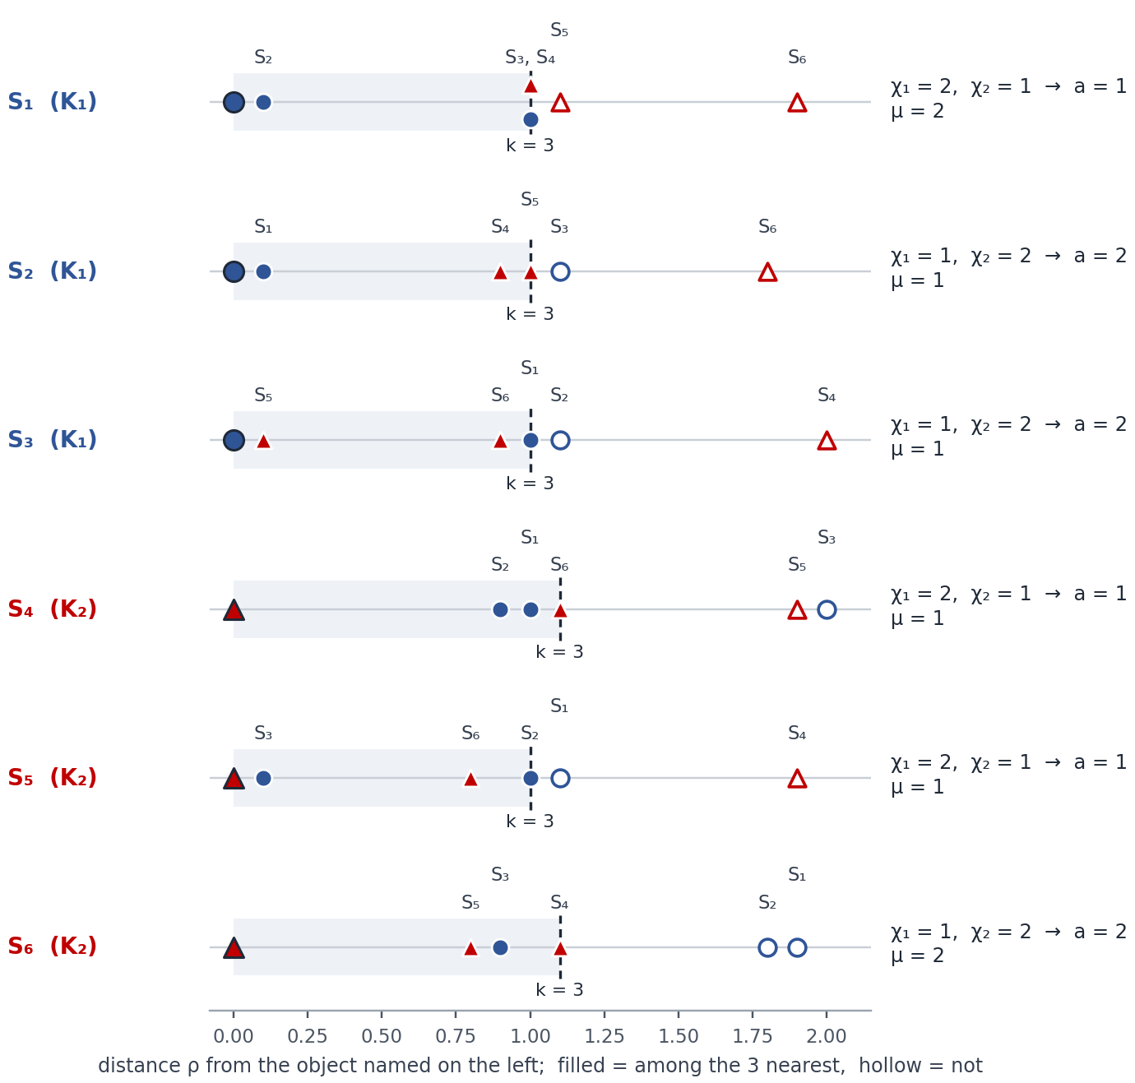
Figure 3. The same neighbourhoods by ρ as distance rulers: each row puts the object named on the left at 0 and the other five objects at their distance from it (blue circle = K₁, red triangle = K₂); filled markers are the three nearest (the object itself is the large dark-outlined marker at 0), the dashed line marks the 3rd distance.

6.2 Neighbours by ρ_{I} → feature a₂
Object | 1st | 2nd | 3rd | 4th | 5th | χ₁ | χ₂ | μ
S₁ (K₁) | S₃ 0.0 | S₂ 0.1 | S₅ 0.1 | S₆ 0.9 | S₄ 1.0 | 2 | 1 | 2
S₂ (K₁) | S₅ 0.0 | S₁ 0.1 | S₃ 0.1 | S₆ 0.8 | S₄ 0.9 | 2 | 1 | 2
S₃ (K₁) | S₁ 0.0 | S₂ 0.1 | S₅ 0.1 | S₆ 0.9 | S₄ 1.0 | 2 | 1 | 2
S₄ (K₂) | S₆ 0.1 | S₂ 0.9 | S₅ 0.9 | S₁ 1.0 | S₃ 1.0 | 1 | 2 | 2
S₅ (K₂) | S₂ 0.0 | S₁ 0.1 | S₃ 0.1 | S₆ 0.8 | S₄ 0.9 | 3 | 0 | 0
S₆ (K₂) | S₄ 0.1 | S₂ 0.8 | S₅ 0.8 | S₁ 0.9 | S₃ 0.9 | 1 | 2 | 2
Table 5. Neighbours by ρ_{I}, nearest first; the three that count are shaded in the colour of their class. χ₁, χ₂: neighbours from K₁, K₂; μ: neighbours from the object’s own class.
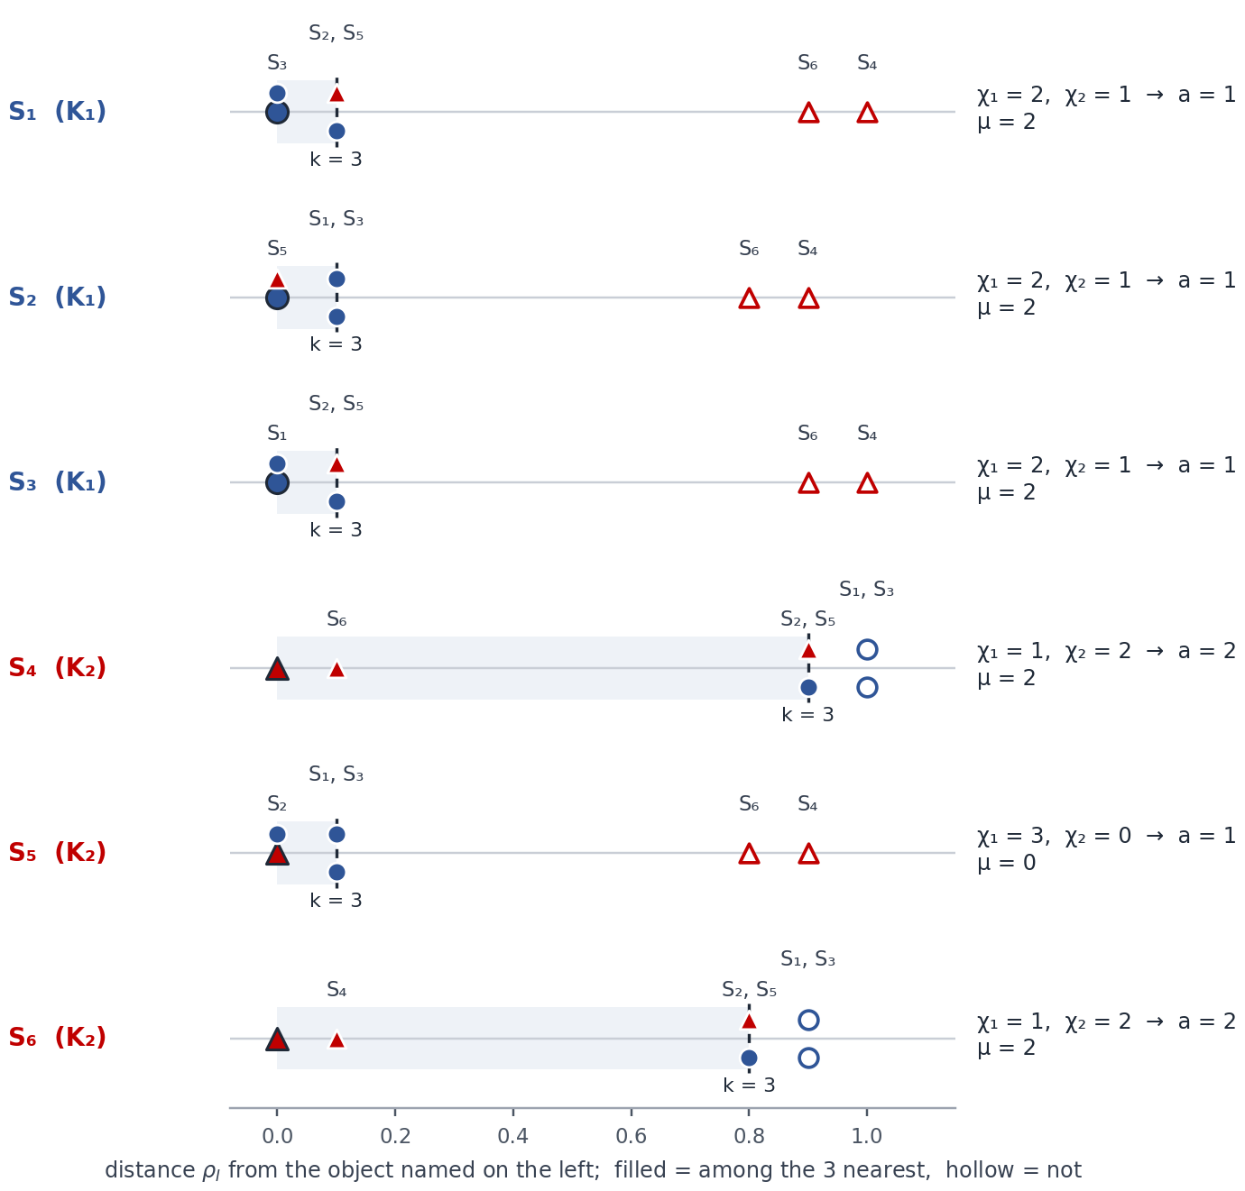
Figure 4. The same neighbourhoods by ρ_{I} as distance rulers: each row puts the object named on the left at 0 and the other five objects at their distance from it (blue circle = K₁, red triangle = K₂); filled markers are the three nearest (the object itself is the large dark-outlined marker at 0), the dashed line marks the 3rd distance.

6.3 Neighbours by ρ_{J} → feature a₃
Object | 1st | 2nd | 3rd | 4th | 5th | χ₁ | χ₂ | μ
S₁ (K₁) | S₂ 0.0 | S₄ 0.0 | S₃ 1.0 | S₅ 1.0 | S₆ 1.0 | 2 | 1 | 2
S₂ (K₁) | S₁ 0.0 | S₄ 0.0 | S₃ 1.0 | S₅ 1.0 | S₆ 1.0 | 2 | 1 | 2
S₃ (K₁) | S₅ 0.0 | S₆ 0.0 | S₁ 1.0 | S₂ 1.0 | S₄ 1.0 | 1 | 2 | 1
S₄ (K₂) | S₁ 0.0 | S₂ 0.0 | S₃ 1.0 | S₅ 1.0 | S₆ 1.0 | 3 | 0 | 0
S₅ (K₂) | S₃ 0.0 | S₆ 0.0 | S₁ 1.0 | S₂ 1.0 | S₄ 1.0 | 2 | 1 | 1
S₆ (K₂) | S₃ 0.0 | S₅ 0.0 | S₁ 1.0 | S₂ 1.0 | S₄ 1.0 | 2 | 1 | 1
Table 6. Neighbours by ρ_{J}, nearest first; the three that count are shaded in the colour of their class. χ₁, χ₂: neighbours from K₁, K₂; μ: neighbours from the object’s own class.
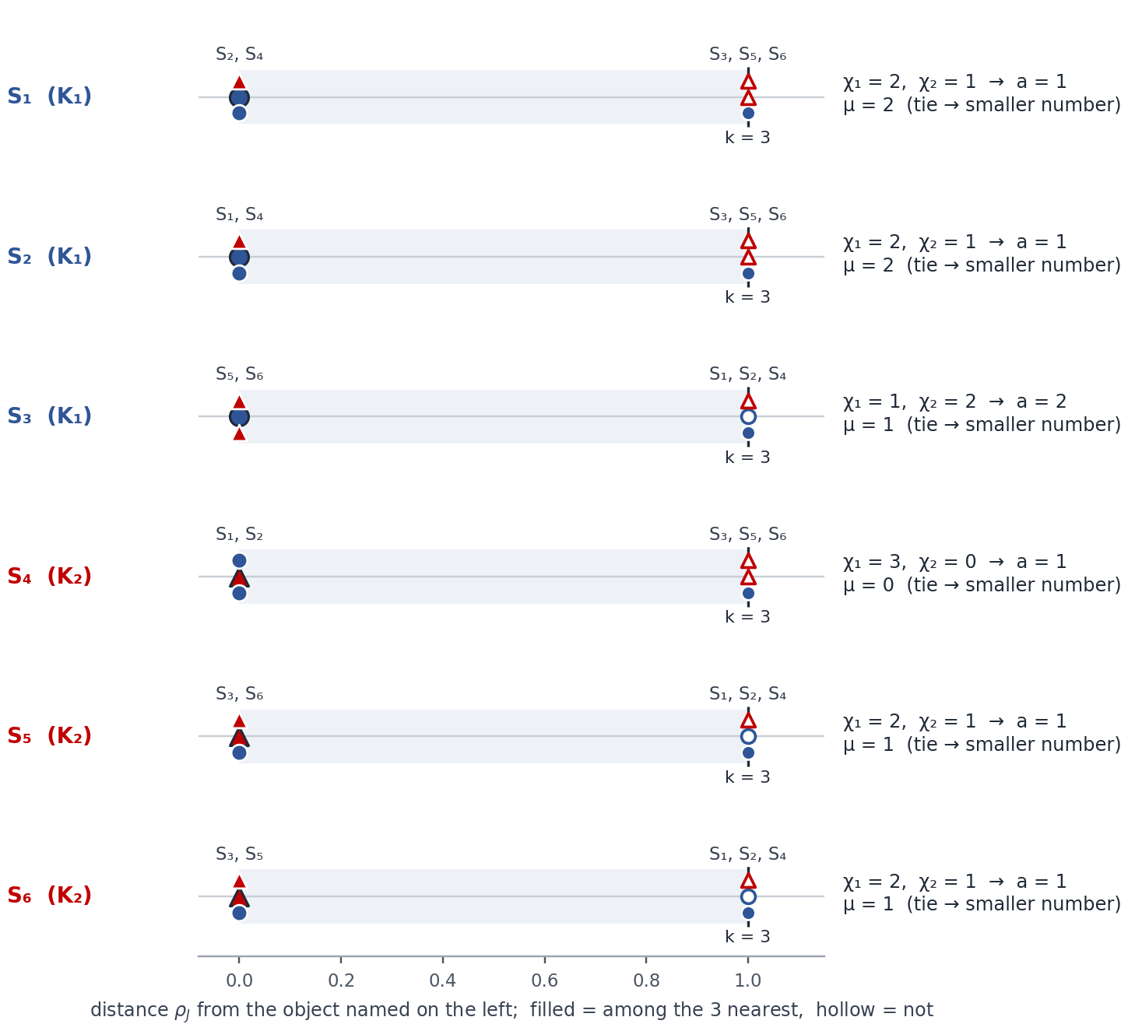
Figure 5. The same neighbourhoods by ρ_{J} as distance rulers: each row puts the object named on the left at 0 and the other five objects at their distance from it (blue circle = K₁, red triangle = K₂); filled markers are the three nearest (the object itself is the large dark-outlined marker at 0), the dashed line marks the 3rd distance.
Where the tie rule decides. Under ρ_{J} every distance is 0 or 1, so each object has exactly two objects at distance 0 (the same label of x₂) and three at distance 1 — the 3rd neighbour is always chosen by the object number. For S₁: S₂ and S₄ are at 0, and S₃, S₅ and S₆ are all at 1; the smallest number, S₃, becomes the 3rd neighbour. Had S₅ (class K₂) been taken instead, χ₁ of S₁ would be 1 instead of 2 and its feature value would flip from 1 to 2. Under ρ and ρ_{I} the ties in this example (for instance S₃ and S₄ both at 1.0 from S₁ under ρ) fall inside the first three places or wholly after them, and change nothing.

7. Step 2 · Formula (5): the synthetic features a
a = 1 if χ₁(S_{j}, k) > [k/2]; a = 2 if χ₂(S_{j}, k) > [k/2] (5)
Here [k/2] = [3/2] = 1, so a = 1 when at least two of the three neighbours come from K₁, and a = 2 when at least two come from K₂. Because k is odd, one of the two always holds — the vote can never be a tie.
Object | Class | a₁ = (ρ, 3) | a₂ = (ρ_{I}, 3) | a₃ = (ρ_{J}, 3)
S₁ | K₁ | χ₁ = 2 > 1 → 1 | χ₁ = 2 > 1 → 1 | χ₁ = 2 > 1 → 1
S₂ | K₁ | χ₂ = 2 > 1 → 2 | χ₁ = 2 > 1 → 1 | χ₁ = 2 > 1 → 1
S₃ | K₁ | χ₂ = 2 > 1 → 2 | χ₁ = 2 > 1 → 1 | χ₂ = 2 > 1 → 2
S₄ | K₂ | χ₁ = 2 > 1 → 1 | χ₂ = 2 > 1 → 2 | χ₁ = 3 > 1 → 1
S₅ | K₂ | χ₁ = 2 > 1 → 1 | χ₁ = 3 > 1 → 1 | χ₁ = 2 > 1 → 1
S₆ | K₂ | χ₂ = 2 > 1 → 2 | χ₂ = 2 > 1 → 2 | χ₁ = 2 > 1 → 1
Table 7. The synthetic features of all objects. Amber: the neighbourhood votes for the other class than the object’s own.
In plain words. The value a is the class most of the object’s neighbours belong to. It ignores the object’s own class, so it can be wrong about the object: under ρ the vote disagrees with the class for S₂, S₃, S₄ and S₅, under ρ_{I} for S₅, and under ρ_{J} for S₃, S₄, S₅ and S₆. How much such a feature can be trusted is measured next, with the classes known.

8. Step 3 · Formula (1): the membership function
f_{k}(μ) = ( d_{1k}(μ) / |K₁| ) / ( d_{1k}(μ) / |K₁| + d_{2k}(μ) / |K₂| ) (1)
For every gradation μ = 0, 1, 2, 3: d_{1k}(μ) and d_{2k}(μ) are the numbers of K₁ and K₂ objects whose μ has that value. Dividing by the class sizes makes the classes comparable even when they differ in size; here both have 3 objects, so f is simply d₁ / (d₁ + d₂). A gradation that no object has is skipped.

a₁ = (ρ, 3)
μ | Objects with this μ | d₁ | d₂ | f₃(μ) by (1) | f
0 | — | 0 | 0 | no object — not used | —
1 | S₂ (K₁), S₃ (K₁), S₄ (K₂), S₅ (K₂) | 2 | 2 | (2/3) / (2/3 + 2/3) | 1/2 = 0.5
2 | S₁ (K₁), S₆ (K₂) | 1 | 1 | (1/3) / (1/3 + 1/3) | 1/2 = 0.5
3 | — | 0 | 0 | no object — not used | —

a₂ = (ρ_{I}, 3)
μ | Objects with this μ | d₁ | d₂ | f₃(μ) by (1) | f
0 | S₅ (K₂) | 0 | 1 | (0/3) / (0/3 + 1/3) | 0
1 | — | 0 | 0 | no object — not used | —
2 | S₁ (K₁), S₂ (K₁), S₃ (K₁), S₄ (K₂), S₆ (K₂) | 3 | 2 | (3/3) / (3/3 + 2/3) | 3/5 = 0.6
3 | — | 0 | 0 | no object — not used | —

a₃ = (ρ_{J}, 3)
μ | Objects with this μ | d₁ | d₂ | f₃(μ) by (1) | f
0 | S₄ (K₂) | 0 | 1 | (0/3) / (0/3 + 1/3) | 0
1 | S₃ (K₁), S₅ (K₂), S₆ (K₂) | 1 | 2 | (1/3) / (1/3 + 2/3) | 1/3 ≈ 0.3333
2 | S₁ (K₁), S₂ (K₁) | 2 | 0 | (2/3) / (2/3 + 0/3) | 1
3 | — | 0 | 0 | no object — not used | —

Table 8. Membership of every gradation for the three features.
In plain words. f tells how strongly a gradation points to K₁: f = 1 — only K₁ objects have it; f = 0 — only K₂ objects; f = 0.5 — both classes equally, so it says nothing. The example shows all of these, plus mixed values on both sides of 0.5: 0.6 (a₂, μ = 2) and 1/3 (a₃, μ = 1).
In a₁ both gradations that occur are shared equally by the two classes, so every f is 0.5 — the first sign that this feature will be useless.

9. Step 4 · Formula (2): the stability of a feature
g_{k} = (1/m) · Σ_{μ = 0 … β} n(μ) · { f_{k}(μ) if f_{k}(μ) ≥ 0.5; 1 − f_{k}(μ) if f_{k}(μ) < 0.5 } (2)
n(μ) = d_{1k}(μ) + d_{2k}(μ) is the number of objects with gradation μ, and β = k for this kind of feature (§1.4). Each gradation adds its size times the larger of f and 1 − f; gradations without objects add nothing.
g₃ of a₁ = (4·1/2 + 2·1/2) / 6 = 3 / 6 = 0.5000
g₃ of a₂ = (1·1 + 5·3/5) / 6 = 4 / 6 = 0.6667
g₃ of a₃ = (1·1 + 3·2/3 + 2·1) / 6 = 5 / 6 = 0.8333
Why? g_{k} lies between 0.5 and 1: 0.5 means the gradations do not tell the classes apart, 1 means every gradation belongs to one class only. Following §1.4, the stabilities of the features describe the training sample as a whole — a “meta-object” that can be compared with other samples. The value is not passed to the grouping.

10. Step 5 · Formula (3): the boundary between the classes
G_{k} = (q₁ + q₂) / 2, q₂ = max{ f_{k}(μ) | f_{k}(μ) < 0.5 }, q₁ = min{ f_{k}(μ) | f_{k}(μ) > 0.5 } (3)
q₂ is the highest membership that still points to K₂, q₁ the lowest that points to K₁; the boundary G lies halfway between them on the f axis.
Feature | q₂ (below 0.5) | q₁ (above 0.5) | Calculation | G
a₁ | none | none | formula (3) has no value; the workbook uses G = 0.5 | 0.5
a₂ | 0 | 0.6 | (0.6 + 0) / 2 | 0.3
a₃ | 1/3 | 1 | (1 + 1/3) / 2 | 2/3 ≈ 0.6667
Table 9. The boundary of each feature.
When one side is empty. For a₁ no membership lies below 0.5 and none above it, so formula (3) cannot be evaluated; the article does not say what to do. The workbook then uses G = 0.5, the neutral middle of the f axis.
One side can never be empty on its own, whatever the class sizes. Every object has exactly one gradation, so the shares d_{1k}(μ) / |K₁| add up to 1 over all μ, and so do the shares d_{2k}(μ) / |K₂|. If no gradation leaned to K₂, the K₁ share would be at least the K₂ share for every μ — and since both add up to 1, they must be equal everywhere: every f is 0.5. So an empty side always means a feature like a₁, and with G = 0.5 such a feature always gets ω = 0.

11. Step 6 · Formula (4): the weight of a feature
ω_{[k/2]} = ( |{S ∈ K₁ : g(S, k) > G_{k}}| + |{S ∈ K₂ : g(S, k) < G_{k}}| ) / |K₁ ∪ K₂| (4)
g(S, k) = f_{k}(μ) is the membership of the object S at its own gradation. A K₁ object counts when it lies above the boundary, a K₂ object when it lies below it. The inequalities are strict, so an object exactly on G counts for neither class.

a₁ = (ρ, 3): G = 0.5
Object | Class | μ | f = g(S, 3) | compared with G | Counted?
S₁ | K₁ | 2 | 0.5 | 0.5 = 0.5 | ○ on G — not counted
S₂ | K₁ | 1 | 0.5 | 0.5 = 0.5 | ○ on G — not counted
S₃ | K₁ | 1 | 0.5 | 0.5 = 0.5 | ○ on G — not counted
S₄ | K₂ | 1 | 0.5 | 0.5 = 0.5 | ○ on G — not counted
S₅ | K₂ | 1 | 0.5 | 0.5 = 0.5 | ○ on G — not counted
S₆ | K₂ | 2 | 0.5 | 0.5 = 0.5 | ○ on G — not counted
ω of a₁ = 0 / 6 = 0

a₂ = (ρ_{I}, 3): G = 0.3
Object | Class | μ | f = g(S, 3) | compared with G | Counted?
S₁ | K₁ | 2 | 0.6 | 0.6 > 0.3 | ✓ correct side
S₂ | K₁ | 2 | 0.6 | 0.6 > 0.3 | ✓ correct side
S₃ | K₁ | 2 | 0.6 | 0.6 > 0.3 | ✓ correct side
S₄ | K₂ | 2 | 0.6 | 0.6 > 0.3 | ✗ wrong side
S₅ | K₂ | 0 | 0 | 0 < 0.3 | ✓ correct side
S₆ | K₂ | 2 | 0.6 | 0.6 > 0.3 | ✗ wrong side
ω of a₂ = 4 / 6 = 0.6667

a₃ = (ρ_{J}, 3): G = 2/3
Object | Class | μ | f = g(S, 3) | compared with G | Counted?
S₁ | K₁ | 2 | 1 | 1 > 2/3 | ✓ correct side
S₂ | K₁ | 2 | 1 | 1 > 2/3 | ✓ correct side
S₃ | K₁ | 1 | 1/3 | 1/3 < 2/3 | ✗ wrong side
S₄ | K₂ | 0 | 0 | 0 < 2/3 | ✓ correct side
S₅ | K₂ | 1 | 1/3 | 1/3 < 2/3 | ✓ correct side
S₆ | K₂ | 1 | 1/3 | 1/3 < 2/3 | ✓ correct side
ω of a₃ = 5 / 6 = 0.8333
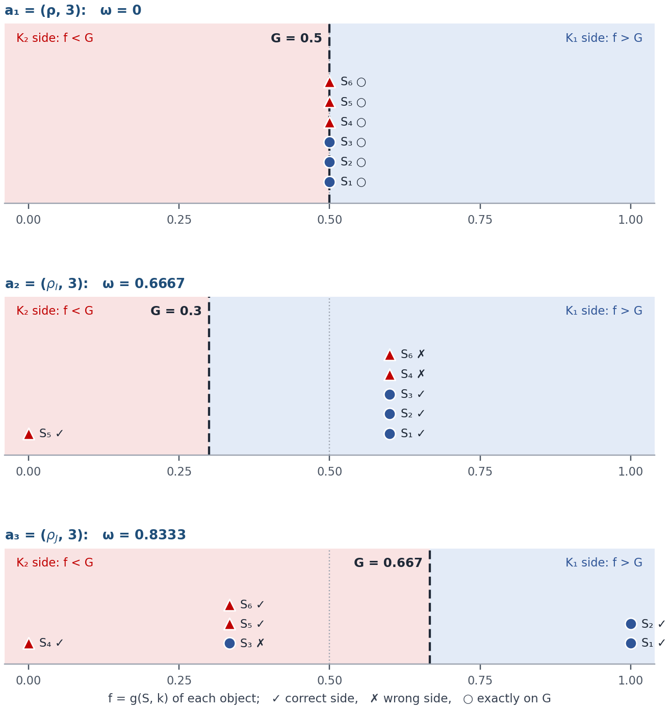
Figure 6. Every object placed at its membership f, with the boundary G (dashed). Right of G is the K₁ side, left of it the K₂ side; ✓ correct side, ✗ wrong side, ○ exactly on G.
In plain words. ω is the share of objects that the boundary puts on the side of their own class; it becomes the weight of the feature. a₁ gets ω = 0 because every object sits exactly on its boundary. In a₂ the boundary is low (G = 0.3), so the K₂ objects S₄ and S₆ with f = 0.6 end up on the K₁ side. In a₃ the K₁ object S₃ is on the wrong side.
Unlike the stability g, which never falls below 0.5, the weight can drop to 0.

12. Step 7 · Formula (6): the contribution of each value
η_{[k/2]}(j) = ω_{[k/2]} · ( α¹_{j} / |K₁| − α²_{j} / |K₂| ), j ∈ {1, 2} (6)
α¹_{j} and α²_{j} count the K₁ and K₂ objects whose feature value is a = j. The bracket compares how common the value j is in each class, as a share of the class; ω scales the result by the worth of the feature.

a₁ = (ρ, 3): ω = 0
Values in K₁ (S₁, S₂, S₃): 1, 2, 2; in K₂ (S₄, S₅, S₆): 1, 1, 2.
η(1) = 0 · (1/3 − 2/3) = 0
η(2) = 0 · (2/3 − 1/3) = 0

a₂ = (ρ_{I}, 3): ω = 2/3
Values in K₁ (S₁, S₂, S₃): 1, 1, 1; in K₂ (S₄, S₅, S₆): 2, 1, 2.
η(1) = 2/3 · (3/3 − 1/3) = +0.4444
η(2) = 2/3 · (0/3 − 2/3) = −0.4444

a₃ = (ρ_{J}, 3): ω = 5/6
Values in K₁ (S₁, S₂, S₃): 1, 1, 2; in K₂ (S₄, S₅, S₆): 1, 1, 1.
η(1) = 5/6 · (2/3 − 3/3) = −0.2778
η(2) = 5/6 · (1/3 − 0/3) = +0.2778
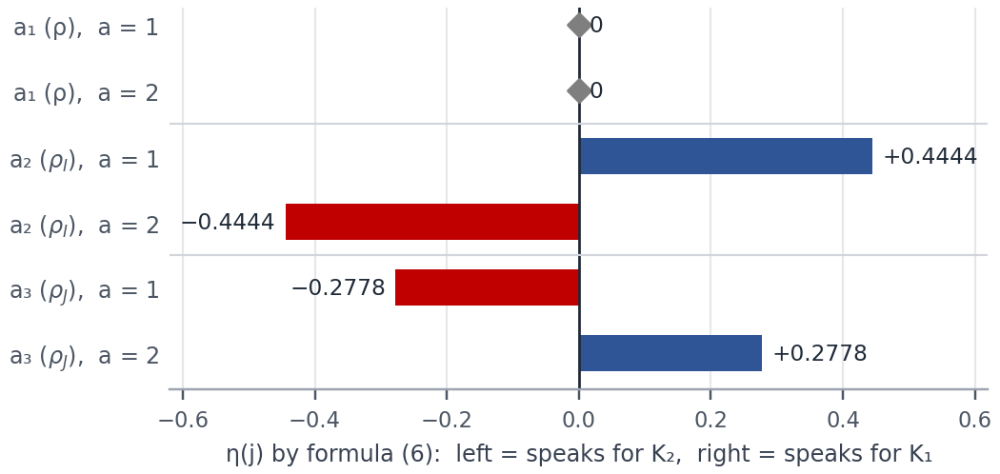
Figure 7. The contributions of the two values of every feature. Bars to the right point to K₁, bars to the left to K₂; a₁ contributes nothing.
In plain words. In a₂ the value 1 is held by all three K₁ objects but by only one K₂ object, so it points to K₁ (η(1) = +0.4444) and the value 2 points to K₂.
In a₃ the signs are reversed: the value a = 1 — “most neighbours are from K₁” — is held by all three K₂ objects but by only two of the K₁ objects, so in this sample the value 1 points to K₂ (η(1) = −0.2778). Formula (6) looks at how the values are spread over the classes, not at what they mean.
In a₁ the weight ω = 0 makes both contributions 0.

13. The result: the input of the grouping
The article states that the input of the hierarchical agglomerative algorithm is “the set of synthetic features Ψ(r), their informativeness (4) and the contributions by gradations (6)” (§1.5). In practice every value a of a feature is replaced by its contribution η(a):
Object | Class | a₁ = (ρ, 3) | a₂ = (ρ_{I}, 3) | a₃ = (ρ_{J}, 3)
S₁ | K₁ | a = 1 → 0 | a = 1 → +0.4444 | a = 1 → −0.2778
S₂ | K₁ | a = 2 → 0 | a = 1 → +0.4444 | a = 1 → −0.2778
S₃ | K₁ | a = 2 → 0 | a = 1 → +0.4444 | a = 2 → +0.2778
S₄ | K₂ | a = 1 → 0 | a = 2 → −0.4444 | a = 1 → −0.2778
S₅ | K₂ | a = 1 → 0 | a = 1 → +0.4444 | a = 1 → −0.2778
S₆ | K₂ | a = 2 → 0 | a = 2 → −0.4444 | a = 1 → −0.2778
Weight ω |  | 0 | 0.6667 | 0.8333
Table 10. Ψ(r) as contributions, with the weights — the data the grouping receives. Blue: the value points to K₁; red: to K₂; grey: no contribution.
What the grouping does with it. Its Step 2 starts from the feature with the largest weight — here a₃ (ω = 0.8333) — and copies its contributions into the first latent feature R(S_{t}). It then tries each remaining feature as b = R + η, corrects the values with the majorizing function and keeps the feature that gives the smallest ratio θ/γ of within-class similarity to between-class difference. a₁ carries no information of its own (ω = 0, every contribution 0), yet adding it still changes R through the majorizing function b + α·φ(−b) for K₁ and b − α·φ(−b) for K₂, with φ the logistic function. With α = 0.3 as in the workbook — and also with α = 0.2, the value used in §3 of the article — the article’s version of the grouping chooses a₁ second here; for α below about 0.14, or without the majorizing step, a₂ would come second. The grouping itself is worked through in the Context-Synthetic Model workbook.

14. The whole calculation at a glance
 | a₁ = (ρ, 3) | a₂ = (ρ_{I}, 3) | a₃ = (ρ_{J}, 3)
a for S₁ … S₆ | 1, 2, 2, 1, 1, 2 | 1, 1, 1, 2, 1, 2 | 1, 1, 2, 1, 1, 1
μ for S₁ … S₆ | 2, 1, 1, 1, 1, 2 | 2, 2, 2, 2, 0, 2 | 2, 2, 1, 0, 1, 1
f by (1) | f(1) = 0.5, f(2) = 0.5 | f(0) = 0, f(2) = 0.6 | f(0) = 0, f(1) = 1/3, f(2) = 1
g by (2) | 0.5000 | 0.6667 | 0.8333
G by (3) | 0.5 (no q₁, q₂) | 0.3 | 2/3
ω by (4) | 0 | 0.6667 | 0.8333
η(1), η(2) by (6) | 0, 0 | +0.4444, −0.4444 | −0.2778, +0.2778
Table 11. Every result of the three features side by side.
Every situation of the calculation appears in the example:
# | Situation | Step | Seen in
1 | both values a = 1 and a = 2 occur (formula (5)) | Step 2 | a₁, a₂, a₃
2 | the neighbourhood votes for the other class than the object’s own | Step 2 | a₁, a₂, a₃
3 | a gradation that no object has (skipped) | Step 3 | a₁, a₂, a₃
4 | f = 1: a gradation only K₁ objects have | Step 3 | a₃
5 | f = 0: a gradation only K₂ objects have | Step 3 | a₂, a₃
6 | f = 0.5: a gradation shared equally | Step 3 | a₁
7 | 0 < f < 0.5: mixed, leaning to K₂ | Step 3 | a₃
8 | 0.5 < f < 1: mixed, leaning to K₁ | Step 3 | a₂
9 | boundary with values on both sides of 0.5 | Step 5 | a₂, a₃
10 | boundary with an empty side — then every f = 0.5 (G = 0.5 by the workbook’s rule) | Step 5 | a₁
11 | an object exactly on G (counted for neither class) | Step 6 | a₁
12 | a K₁ object on the correct side | Step 6 | a₂, a₃
13 | a K₁ object on the wrong side | Step 6 | a₃
14 | a K₂ object on the correct side | Step 6 | a₂, a₃
15 | a K₂ object on the wrong side | Step 6 | a₂
16 | value 1 points to K₁, value 2 to K₂ | Step 7 | a₂
17 | reversed: value 1 points to K₂ | Step 7 | a₃
18 | a zero contribution (here because ω = 0) | Step 7 | a₁
19 | objects tied for the 3rd and 4th places, decided by the object number | Step 1 | a₃
Table 12. The 19 situations of forming a synthetic feature, and where each of them occurs.

15. Why each piece is there
Piece | What it does | How to read it
Min–max rescaling | puts every quantitative feature on [0, 1] | no feature dominates a distance because of its units
ρ, ρ_{I}, ρ_{J} | measure closeness on all features, on the numbers only, on the labels only | different lenses give different neighbours — and different synthetic features
k nearest neighbours | the local context of an object | the synthetic feature describes an object by its surroundings, not by its own values
tie rule | equal distances: the smaller object number first | makes the neighbourhood unique, so the result can be reproduced
χ₁, χ₂ and (5) | majority vote of the neighbours | a class-free value: a new object gets it in the same way
μ | own-class neighbours | how typical the object is for its own class (training sample only)
(1) membership f | how strongly each gradation points to K₁ | 0.5 = the gradation carries no information about the class
(2) stability g | separation of the classes by the gradations, 0.5 … 1 | describes the sample as a meta-object; not used by the grouping
(3) boundary G | threshold on the f axis | splits the gradations that lean to K₂ from those that lean to K₁
(4) weight ω | share of objects on the side of their own class | how much the feature is worth; the grouping starts from the largest ω
(6) contribution η | signed strength of each value a = j | replaces the value in the description of the object
Ψ(r) | all features for every distance and k | the material from which the grouping builds the latent features

16. What the article leaves open
A few details of §1.2–1.5 are not fixed by the text. This guide follows the CS-model workbook in each of them.
Question | Choice used here | Comment
Formulas (1), (2), (5) and (6) are pictures in the draft | The forms of the workbook | They agree with the pictures; written out in Sections 7–9 and 12
Which k are permitted? | Odd k from 3 to 2·min(|K₁|, |K₂|) − 3 (the k rule of the workbook experiments) | The article writes r = |{k | [k/2] − k/2 = 0, k ≤ min(|K₁|, |K₂|)}|. Read literally, [k/2] − k/2 = 0 selects even k, but the vote (5) needs odd k (with even k it can tie), §1.3 uses odd k and the ensemble experiment of §3 uses odd k from 3 to 41; only the stability tables of §3 also use even k. The bound min(|K₁|, |K₂|) also differs from 2·min − 3; here both allow k = 3
Equal distances among neighbours | The smaller object number first | The article asks for “a special deterministic rule” (§1.2); here the rule decides a₃
Boundary (3) when one side is empty | G = 0.5 | Not defined in the article. An empty side always means every f = 0.5 (Section 10); G = 0.5 then gives ω = 0, as for a₁
Objects with f exactly equal to G | Counted for neither class | Follows from the strict inequalities in (4)
β in formula (2) | β = k | §1.2 gives β = 2^{k} − 1 for neighbour codes, §1.4 gives β = k for own-class counts
Two meanings of g | g_{k} = stability (2); g(S, k) = membership of an object in (4) | The same letter is used for different quantities
μ counts own-class neighbours | As written | f then measures how typical an object is rather than which class it is near: if both classes were perfectly separated, every object would have μ = k, every f would be 0.5 and ω would be 0
Numbering of the features | a₁, a₂, a₃ by distance | The article indexes a feature by [k/2]; with three distances per k a second index is needed
A feature with ω = 0 in the grouping | Not excluded | Its contributions are all 0, but adding it still changes R through the majorizing function: with α = 0.3 (or the article’s α = 0.2) the grouping chooses a₁ second here; for α below about 0.14 a₂ comes second

Appendix A. All 15 distances in detail
Every pair with its quantitative term, its nominal term and their sum.
Pair | Classes | ρ_{I}: |x′_{1a} − x′_{1b}| | ρ_{J}: [x_{2a} ≠ x_{2b}] | ρ
S₁ – S₂ | same (K₁) | |0.0 − 0.1| = 0.1 | [1 ≠ 1] = 0 | 0.1
S₁ – S₃ | same (K₁) | |0.0 − 0.0| = 0.0 | [1 ≠ 2] = 1 | 1.0
S₁ – S₄ | different | |0.0 − 1.0| = 1.0 | [1 ≠ 1] = 0 | 1.0
S₁ – S₅ | different | |0.0 − 0.1| = 0.1 | [1 ≠ 2] = 1 | 1.1
S₁ – S₆ | different | |0.0 − 0.9| = 0.9 | [1 ≠ 2] = 1 | 1.9
S₂ – S₃ | same (K₁) | |0.1 − 0.0| = 0.1 | [1 ≠ 2] = 1 | 1.1
S₂ – S₄ | different | |0.1 − 1.0| = 0.9 | [1 ≠ 1] = 0 | 0.9
S₂ – S₅ | different | |0.1 − 0.1| = 0.0 | [1 ≠ 2] = 1 | 1.0
S₂ – S₆ | different | |0.1 − 0.9| = 0.8 | [1 ≠ 2] = 1 | 1.8
S₃ – S₄ | different | |0.0 − 1.0| = 1.0 | [2 ≠ 1] = 1 | 2.0
S₃ – S₅ | different | |0.0 − 0.1| = 0.1 | [2 ≠ 2] = 0 | 0.1
S₃ – S₆ | different | |0.0 − 0.9| = 0.9 | [2 ≠ 2] = 0 | 0.9
S₄ – S₅ | same (K₂) | |1.0 − 0.1| = 0.9 | [1 ≠ 2] = 1 | 1.9
S₄ – S₆ | same (K₂) | |1.0 − 0.9| = 0.1 | [1 ≠ 2] = 1 | 1.1
S₅ – S₆ | same (K₂) | |0.1 − 0.9| = 0.8 | [2 ≠ 2] = 0 | 0.8

Appendix B. The procedure in pseudocode
The reading used in this guide, written so that it can be turned into Python directly.
input: objects S[1..m], classes y[1..m], feature types, permitted k values
rescale quantitative features: x' = (x - min) / (max - min)

for each distance op in (rho, rho_I, rho_J):
for each permitted k: # one synthetic feature
for each object i:
nb = other objects sorted by (distance(op, i, j), j)[:k]
chi1[i] = count of j in nb with y[j] == 1; chi2[i] = k - chi1[i]
a[i] = 1 if chi1[i] > k // 2 else 2 # formula (5)
mu[i] = chi1[i] if y[i] == 1 else chi2[i] # own-class count
for mu_val in 0..k: # formula (1)
d1, d2 = objects of K1, K2 with mu == mu_val
f[mu_val] = (d1/|K1|) / (d1/|K1| + d2/|K2|) if d1 + d2 > 0
g = sum(n(mu) * max(f, 1 - f)) / m # formula (2)
q2 = max(f < 0.5); q1 = min(f > 0.5)
G = (q1 + q2) / 2 if both exist else 0.5 # formula (3)
w = (#K1 with f[mu] > G + #K2 with f[mu] < G) / m # formula (4)
for j in (1, 2): # formula (6)
eta[j] = w * (#K1 with a == j / |K1| - #K2 with a == j / |K2|)
column = [eta[a[i]] for each object i]

output: Psi(r) = contribution columns + weights w -> hierarchical grouping

Appendix C. The example as a data file
The same layout as the data files of the workbooks: the first row is m, n, c; then one row per object (features, then class); the last row holds the type flags (1 = quantitative, 0 = nominal).
6,2,2
10,1,1
20,1,1
10,2,1
110,1,2
20,2,2
100,2,2
1,0

Appendix D. Where each step lives in the CS-model workbook
The Context-Synthetic Model workbook runs the same procedure on 10 objects of the Heart-Disease file.
Step | Sheet(s) of the Context-Synthetic Model workbook
Data, k range, operators | Dataset, Quantitative, Nominal, Parameters
Step 0 · rescaling and distances | Normalized Dataset, Zhuravlev Distances
Step 1 · nearest neighbours | Sorted Neighbors (ρ), Sorted Neighbors (ρ_I), Sorted Neighbors (ρ_J), Synthetic Features (k-NN)
Step 2 · formula (5) | Ψ(r) Binary Features
Steps 3–4 · formulas (1) and (2) | Membership & Stability
Steps 5–6 · formulas (3) and (4) | Informativeness ω
Step 7 · formula (6) and the result | Ψ(r) Contribution & Weight
The grouping that follows | Greedy upon Weight (1-Latent) … (4-Latent)

